# Project Perceiving the World through Technology Milestone 3 - Inputs and Feedback

Navigna Reddy Gangumalla

Nehal Anilkumar Kathiriya

Aditya Dixit

**Inputs and Data handling:**

* Tilt Switch
* IR obstacle

**Feedback/output connection:**

* Buzzer
* Vibration

**Full Integration:**

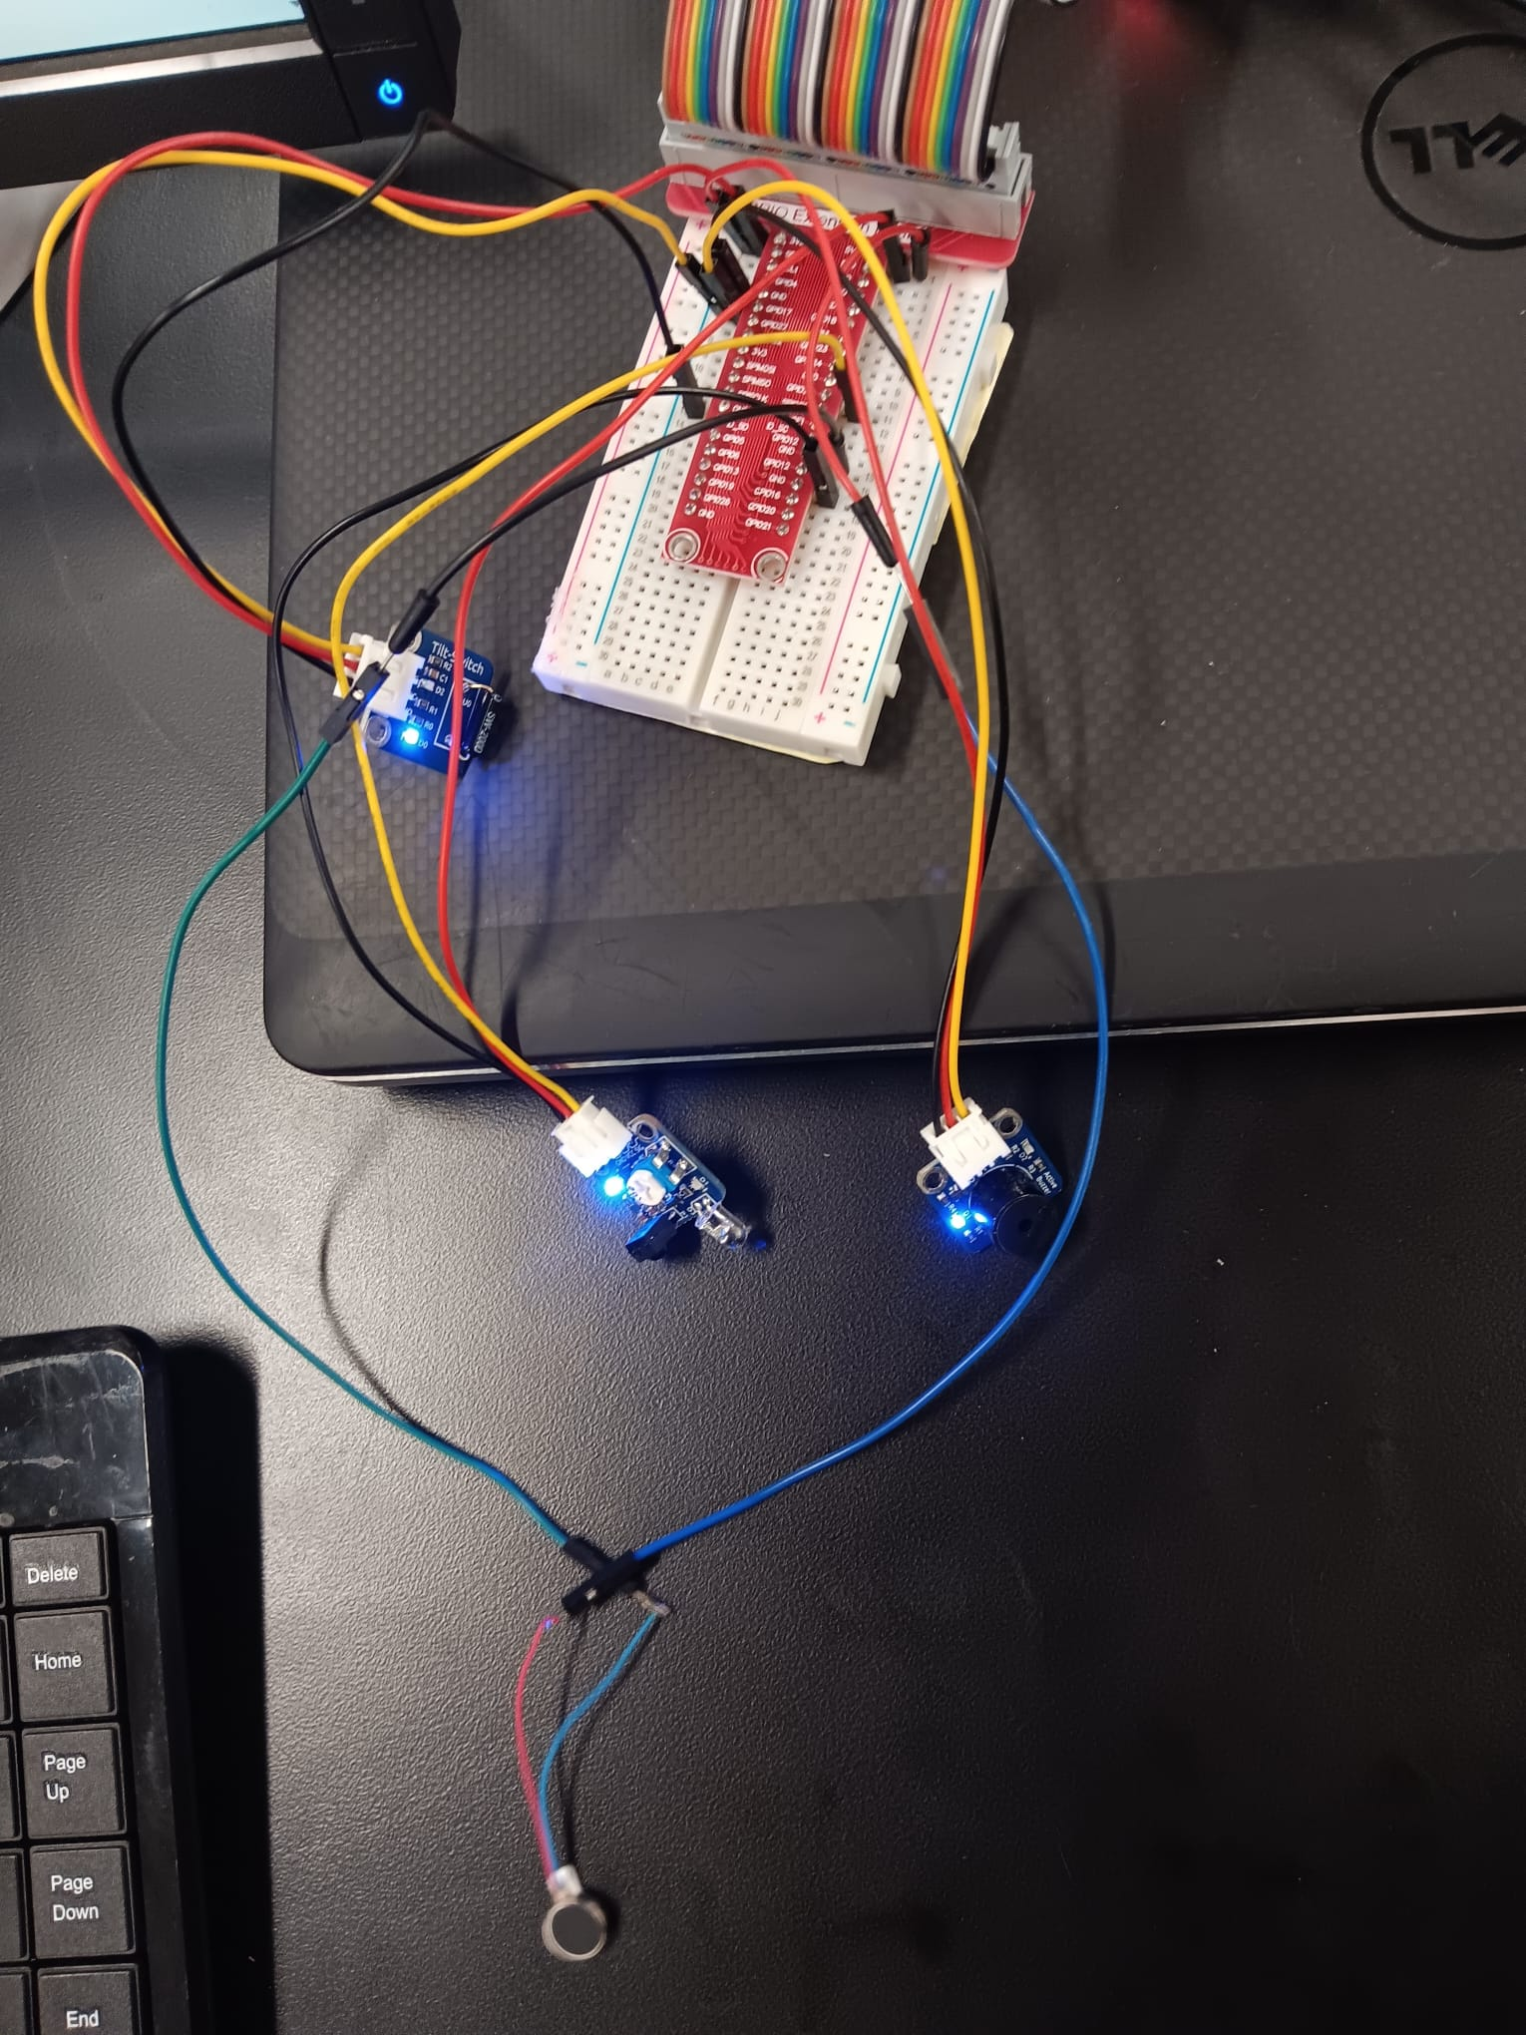

[**https://drive.google.com/file/d/1M8KAhtCa2h6uHHIFiFJxuqk0VqPOZGe3/view?usp=share_link**](https://drive.google.com/file/d/1M8KAhtCa2h6uHHIFiFJxuqk0VqPOZGe3/view?usp=share_link)

**IR obstacle:**

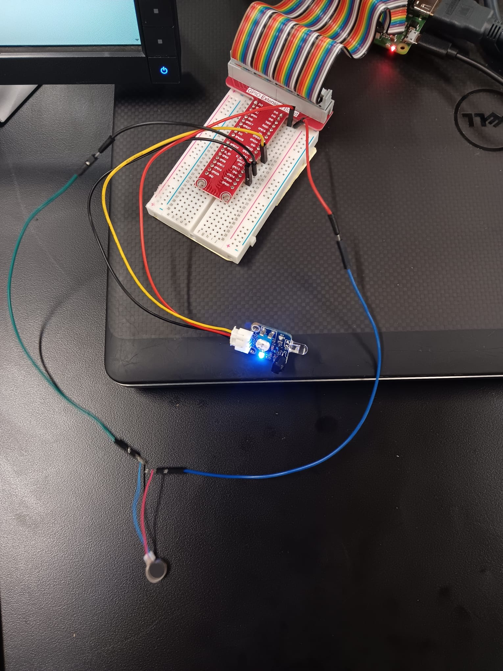

[**https://drive.google.com/file/d/1bjVYvv8i9HPyJV0KfrcP7zdWyv_gZWJ0/view?usp=share_link**](https://drive.google.com/file/d/1bjVYvv8i9HPyJV0KfrcP7zdWyv_gZWJ0/view?usp=share_link)

**Tilt switch:**

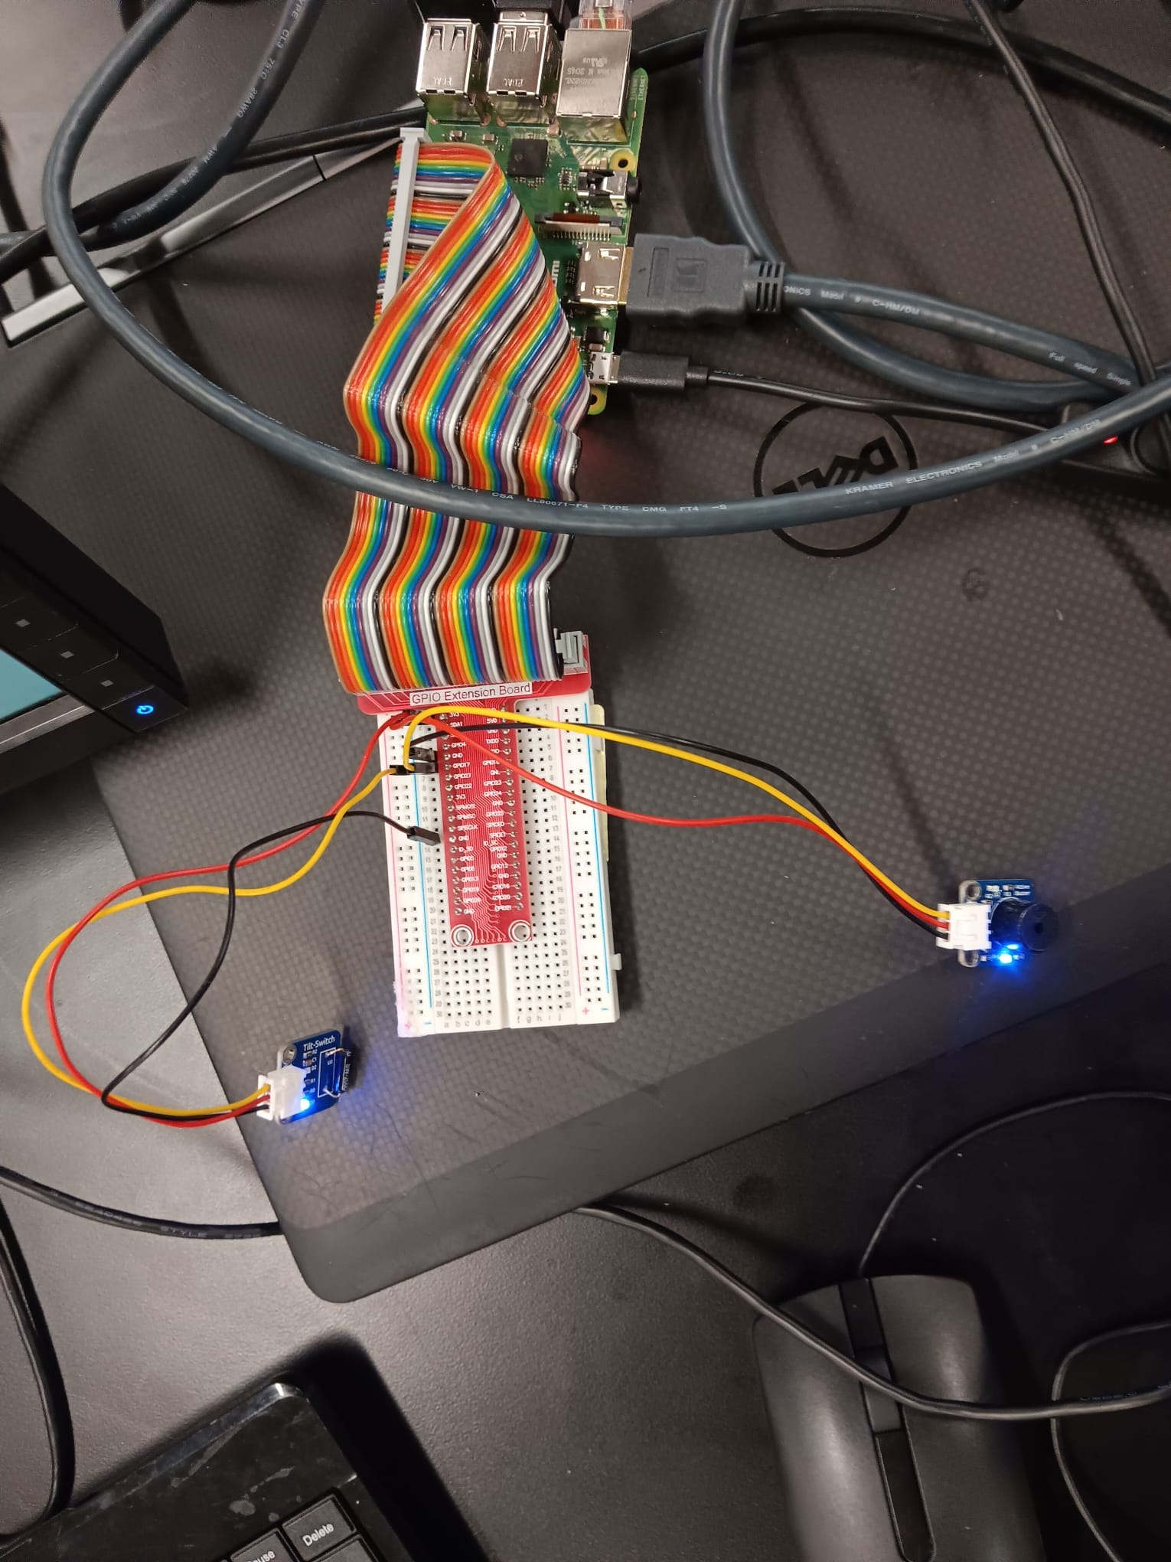[**https://drive.google.com/file/d/1V5ZUOyQgmt5xGCW_LgHfyzVcsz-sxapf/view?usp=share_link**](https://drive.google.com/file/d/1V5ZUOyQgmt5xGCW_LgHfyzVcsz-sxapf/view?usp=share_link)